# Build Documentation

## Intro

This document is to describe structure, design and assumptions made in the creation of the Contact Tracing model through the SCRC/RAMP collaboration.

This model using a SE1E2IaIsRD model with the following transitions allowed:

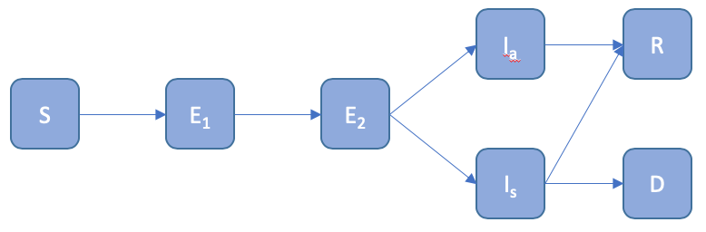

Figure the compartment model

S – Susceptible – the default condition

E1 – Exposed, but not infectious

E2 – Exposed, infectious, but not detectable by a test

Ia – Infected and asymptomatic, will test positive

Is – Infected and symptomatic, will test positive

R – Recovered

D – Dead

The progression through these transitions will be discussed throughout this document.

## Inputs

The inputs are contained in the /inputs folder. They are in two formats, CSV and JSON.

### Contacts.csv

The contact data is a CSV file contain network data that shows contacts between nodes in the network. The columns are time, from, to and weight. An example can be shown in Figure 2. The to and from fields are the ids of the nodes in contact. The weight field is a measure of the duration, intensity or proximity of the contact. This is dimensionless number and is used for determining the spread of the infection and is used for filtering the contacts should a node be alerted. NB. The time and nodes in the CSV file are indexed from 1, the code subtracts 1 so they are zero indexed.

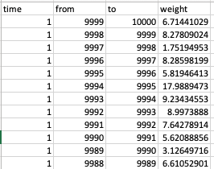

Figure Contacts.csv example

### DiseaseSettings.json

Figure 3 shows the contents of the disease properties file. It shows the mean and max times between compartments of the disease. These are used to vary the propagation between nodes. These values are used with the random number generator to produce distributions based on the progression distribution field. The values for this can be GAUSSIAN, LINEAR, EXPONENTIAL or FLAT. NB LINEAR uses a uniform distribution and FLAT returns the mean.

Exposure threshold is a minimum exposure value that is used to determine if the contact is close enough to spread the infection. This works as a high pass filter value with the weight field.

Exposure tuning is used to scale the weight factor when an exposure occurs. So, if two people interact with the possibility of infection spreading the chance of the spread occurring can be modified by dividing the contact weight by the tuning value.

Random Exposure: this allows a proportion of the population to be randomly exposed from outside the network. This is to simulate people from outside the network interacting. This is the probability per person, per timestep. So, 0.05 is 5 people in a population of 100 per day. This value is likely to be much smaller than 0.05.

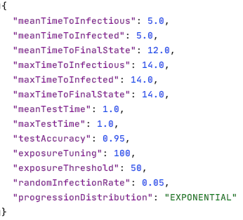

Figure the diseaseSettings.json file

### PopulationSettings.json

An example of the population input can be seen in Figure 4. This file contains three variables.

Population ages: this is a range of ages that make up a proportion of the population, the proportion is given in the population distribution variable

Population distribution: this is the fractional proportion of the population that are in the group.

NB. Both population ages and distribution have to have 5 bins labelled from 0-4.

Gender balance: this is the ratio of men:women, so there are 99 men for every 100 women in this example. This data has been taken from Index Mundi.

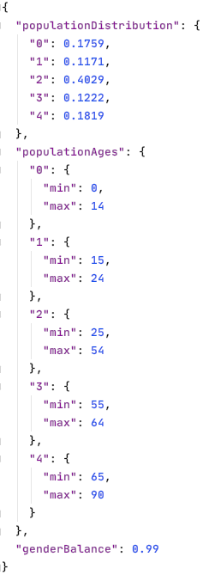

Figure the population input

### RunSettings.json

The run settings file contains the main fields that a user may want to change.

Population size: the number of nodes in a network. This can be larger or smaller than the number of people in the contact network.

Time Limit: this is an absolute limit for how long the simulation will go on in timesteps.

Infected: the number of the population initially infected at t=0. Must be greater than 0.

Seed: the seed for the random number generator. Will be modified by the command line argument if included. This ensure a reproducible output.

Steady state: if there are still active infections when the contact data has been processed, the steady state flag enables the active cases to reach a resolution (recovered or dead) with no further random infections occurring.

Contacts file: points to the CSV file being used in this run.

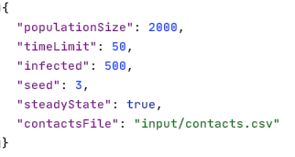

Figure the run settings file

## Virus and Alert Statuses

Following the schema described in 

Figure 1 the status of the virus infections in the code is referred to by an enumeration called Virus Status, which has the options:

* SUSCEPTIBLE
* EXPOSED
* EXPOSED_2
* INFECTED
* INFECTED_SYMP
* RECOVERED
* DEAD

Similarly, the Alert Status that a person is at is described by the enumeration:

* NONE
* ALERTED
* REQUESTED_TEST
* AWAITING_RESULT
* TESTED_POSITIVE

Where the valid transitions are shown in Figure 6.

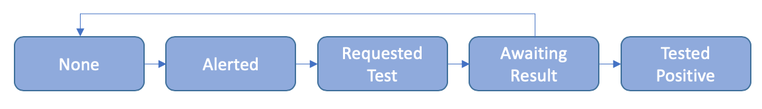

Figure the alert status transitions

## Code Structure

The structure of the model follows the maven/gradle standard project layout as shown in Figure 7.

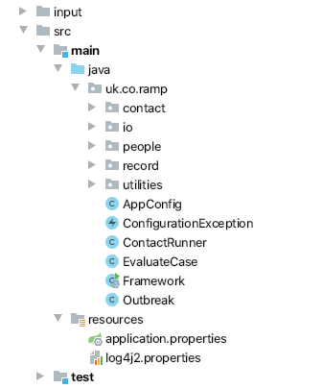

Figure Project and Package Layout

The code is built using the SpringBoot library with the main entry point of the code being Framework.java. After loading and initialising the resources required by the model, it calls ContactRunner.java, which is where the main execution and calculation occurs. This is shown in Figure 8.

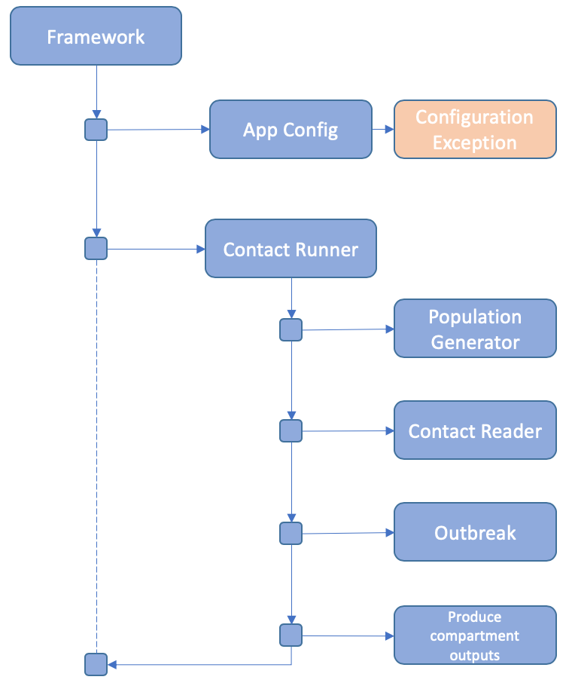

Figure The top-level execution structure

### App Config

This initialised the vital parts of the code that are required for running the model. These include the input parameters for disease, population and execution. It is deemed a critical point of failure should these resources not be loaded, so the code may exit here. A log message is printed describing the error and a Configuration Exception is thrown.

It is worth noting that this is where the command line parameters are dealt with. At the point of writing, the only parameter is a job identifier that can be used to modify the random number seed in a batch job. This parameter is optional.

The input files are described in Inputs.

### Contact Runner

This class initialises the main variables that define the outbreak. These include the population and contact data. These are fed into the Outbreak class, which returns a history of the compartments at each time step. These are output to a csv file.

### Population Generator

The population is parameterised from the population properties file and the run settings. These contain census data on the age and gender breakdown of the population. The size of the population is read from the run settings. The “Human” class contains 4 fields that are populated here:

#### Age

The age is determined from the census data and a uniform random number generator.

|  |  |  |
| --- | --- | --- |
| Age Range | Proportion | Random # Range |
| 0-19 | 0.2 | 0 <= x < 0.2 |
| 20-39 | 0.2 | 0.2<= x <0.4 |
| 40-59 | 0.2 | 0.4 <= x < 0.6 |
| 60-79 | 0.2 | 0.6 <= x < 0.8 |
| 80-99 | 0.2 | 0.8 <= x < 1 |

Table Example population data

For example: using the data in Table 1, if a random number, n = 0.85 is generated the age will be in the range of 80 – 99, amin, amax as the random number is the in range 0.8 <= x < 1. The final age is calculated using

Equation how age is calculated

So, for our example

#### Gender:

The gender balance is read is as a ratio of males to females, so a gender balance of 0.99 means there are 99 men for every 100 women. This is the convention used in census data. The gender is calculated using equation 2, where n is a random number and g is the gender balance

Equation how gender is calculated

#### Health:

At present, health is randomly sampled from a uniform distribution. It may later have some relation to age. A health score of 1 is assumed to be a very healthy individual, a score of 0 is a very frail individual.

#### Compliance

At present, the compliance field is randomly sampled from a uniform distribution. A score of 0 is someone who will ignore any restrictions placed upon them totally, a score of 1 will obey totally.

### Contact Reader

The contact reader reads data from the contact.csv file and generates a map of contacts that occur on any given timestep. This serves as the data that drives the model. The data is also filtered by the maximum number of people in the simulation. For example, a set of contact data may include many millions of people, however if a simulation is only for 10,000 the data for the 10,001+ people are not included in the simulation.

### Outbreak

The outbreak class will be handled in much more detail later on in <<Section XYZ>>. This section will focus purely on the initialisation.

The Outbreak class is a Service Bean, so it is created as part of the App Config section, it is initialised with data in Contact Runner. It requires the population and contact records to be passed to it before the propagate method can be called. This method is what runs through the contact data.

The propagate method returns a map of compartment records for each day, i.e. how many people are in each state of infection.

### Producing compartments output

The compartment data is returned from the outbreak.propagate() method. This is sent to a writer which outputs a CSV file. An example is shown in Figure 9.

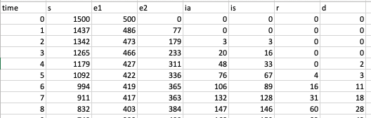

Figure example of CSV output

## Modelling an outbreak

In 4.5 the propagate method was mentioned in passing. The following section fills in the details on how this section works. Figure 10 shows the top level of how the propagation algorithm works and where it calls to. These will be broken down in turn in the following sections.

Upon entering the method, a set of infected cases are created based on the input value from the run settings. These members of the population are randomly sampled and set to EXPOSED to begin the simulation.

Once the initial infections are allocated the runToCompletion method is called. This extracts some key variables from the input parameters, these include:

timeLimit : the maximum duration of the simulation. This will exit the code even if active cases are present. It has the highest precedent. This is to stop any codes hanging should an error occur that is not foreseen.

steadyState: this allows the code to run until there are no active cases (everyone is S, R or D), but will exit if timeLimit is reached.

maxContact: this take the contact data and finds the last time point at which we have a record.

RandomInfectionRate: this is the rate of randomly spawned infections per day.

If the time limit is less than or equal to the max contact time, a warning is logged that not all contact data is used and the steady state flag will be disabled.

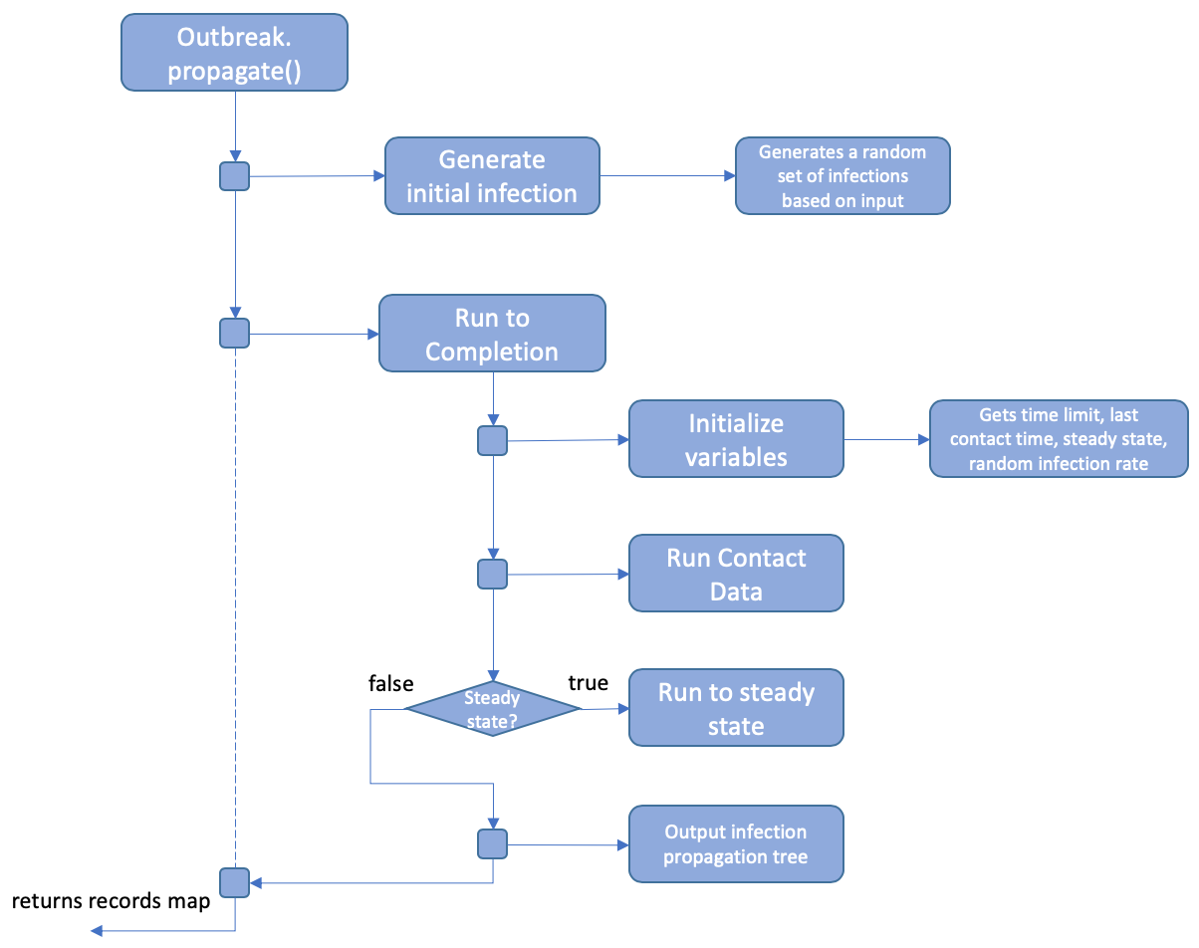

Figure The propagation routine

After this the contact data is run. This will be covered in more depth in section 5.1.

Should the steady state flag be true, and the time limit not reached, it will then call run to steady state solution. This is covered in section 5.2.

Finally, the population data is examined to create a map of infections and how they propagate through the network. To do this, the initial set of seed infections and the random exposures are collected into a set. The population is the searched to look for infections caused by this seed. These in turn are examined recursively after which a map of infection propagation can be output. This can be seen in Figure 11 with some labels.

The first number is the id of the seed infection, the number in rounded brackets is the time they were infected. The square brackets then denote the set of infections caused by the preceding infection. This can be one or many. The following lines then show the infections caused by that set. If the chain ends, it means the final link didn’t infect anyone.

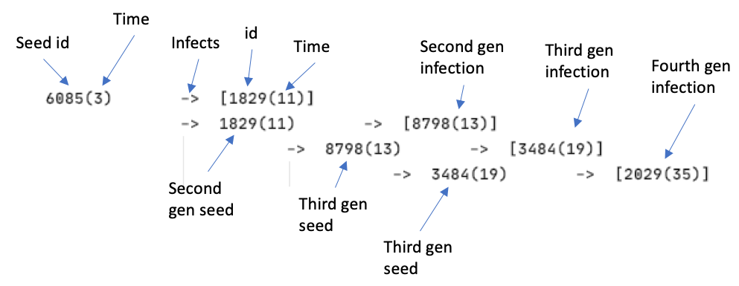

Figure infection map example

### Run Contact Data

Running the propagation of infection is the heart of the calculation. Figure 12 shows the flow of data.

To begin with the update population method is called. This changes the state of any infection that is due to change on this day. This is explained further in 5.3. This is also where random infections are added to the mix. This is done by running a random number test against each susceptible case and setting their status to EXPOSED.

Following this, the contact data for this timestep is extracted along with the number of active cases (those not S, R or D), if this is zero and random infections are off, it will exit here. Otherwise, it will loop over the contact data.

The contact data is evaluated using a series of conditionals. Firstly, the alert status and weight of the contact are reviewed to see if this is a significant contact. If both alert statuses are NONE and the weight of the contact is greater than exposureThreshold, it is a contact of interest. Before evaluating the contact further, the two cases are checked to see if their virus statuses are different, if they are the contact is evaluated.

The two cases are evaluated to see who is in the more severe state, these are described by the rankings:

|  |  |
| --- | --- |
| -1 | DEAD |
| 0 | SUSCEPTIBLE |
| 1 | RECOVERED |
| 2 | EXPOSED |
| 3 | EXPOSED_2 |
| 4 | INFECTED |
| 5 | INFECTED_SYMP |

PersonA is the more severe case; the least severe case is personB. A dangerous mix is when personA is infectious (E2, I, IA) and personB is susceptible. If this is the case, the following test is conducted:

Where n is a random number.

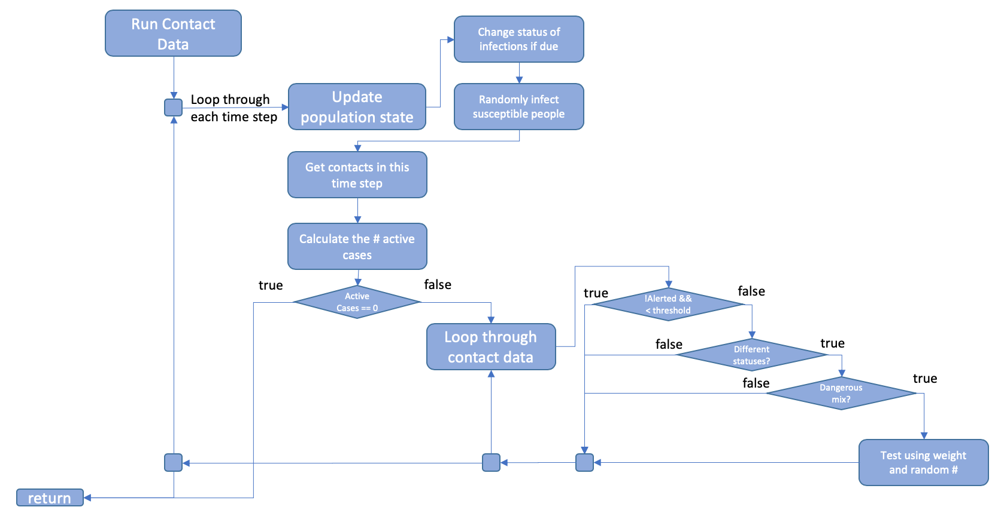

Figure The logic flow for reviewing contact data

### Run to Steady State

During the run to Steady-state routine, shown in Figure 13, updates the population statuses until the existing active cases are resolved, i.e. all active cases resolve in recovery or death. The exit condition is

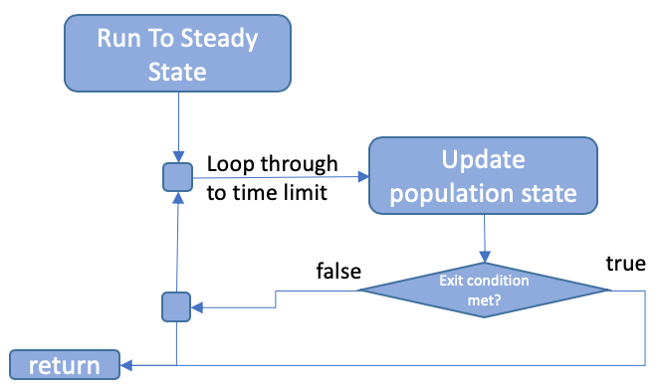

Figure The run to completion algorithm

### Update population

The update population algorithm, shown in Figure 14, is run as part of Run Contact Data and Steady State. Each case has fields containing the next time their statuses change.

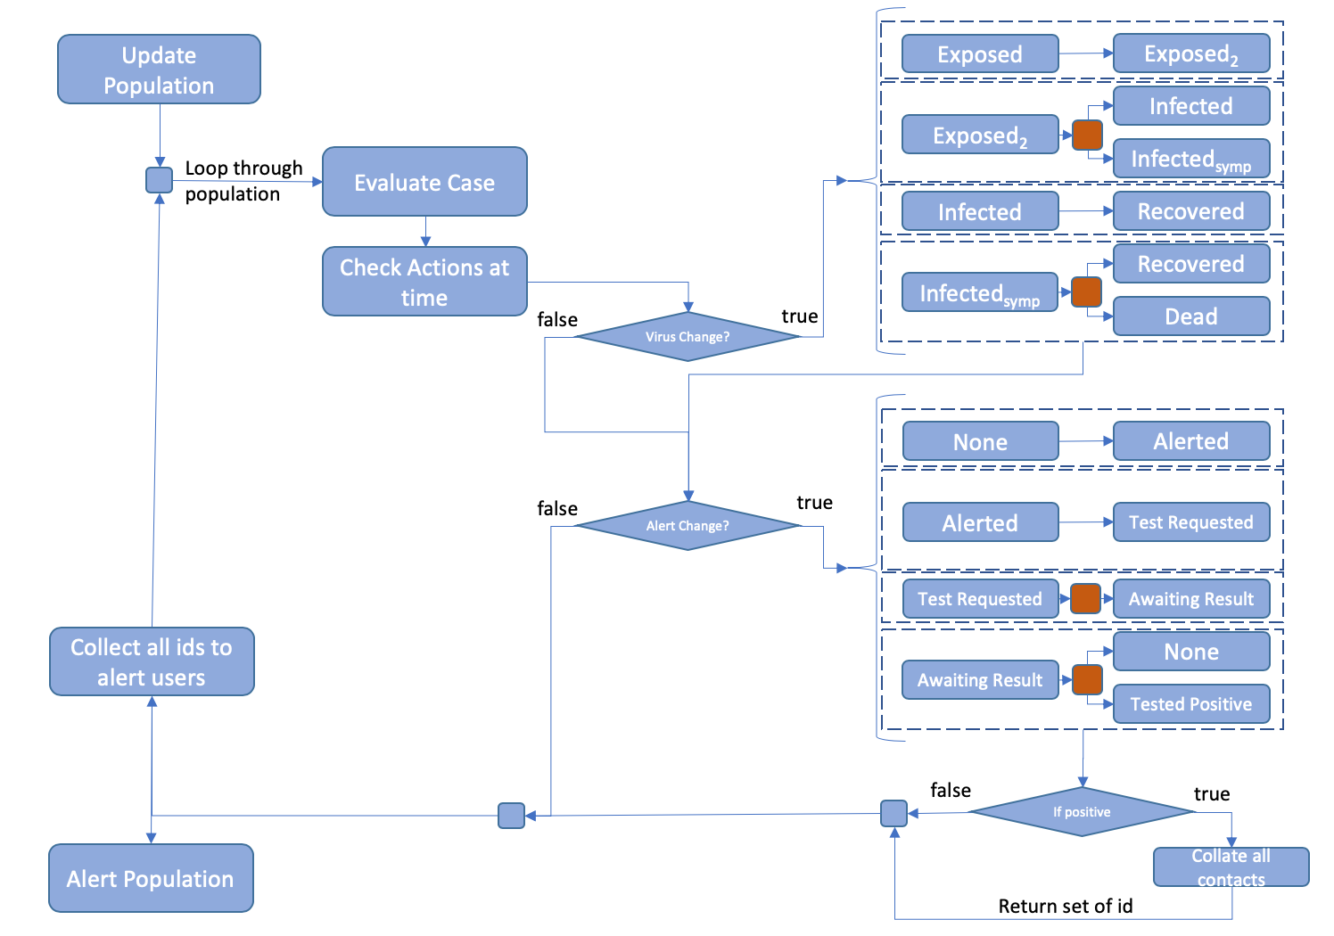

Figure The update population algorithm

#### Virus Status

The virus status is updated first, both Exposed and Infected have a single option, which they progress to, the next status change is calculated using the mean and max times from the disease properties and the chosen random number distribution. Exposed2 and Infectedsump have two options, denoted by the red box. These are chosen by random number, n:

Likewise, the outcome of an Infectedsump is determined by:

#### Alert Status

The alert status only has one choice, the outcome of the test. In this method, the result of the test is determined by the step before, i.e. the recipient of the test needs to be infectious when tested, not when receiving the result. The red box here denotes the storing of a Boolean of ‘wasInfected’ at the time the test was taken. This is then used when the test result is in.

## Assumptions

* At present, contacts do not use the compliance field and obey alert status absolutely.
* A negative test sends the alert status back to NONE.
* Alerts currently go back through all time
* A negative test sets the status back to NONE
* A person tested when not detectable, who subsequently dies does not have their contacts alerted
* Dice roll against health for infection type (gender and age should be included)
* Dice roll against health for recovered/death (gender and age should be included)
* Test positive is the final stage. Should we consider immunity?

## Document version history

Version 1 – drafted 27 May 2020